**Abstract**

This report serves as the fourth deliverable for the Platforms for Computing module and contains three parts to it: notes for the poster explaining how the main components and subsystems of a computer interact with each other, with particular emphasis on Von Neumann architecture, memory hierarchy, and Direct Memory Access; a tutorial for the Snake and Maze simulator, with screenshots and explanations of how it was built, optimized and how it works; a technical brief with full explained solutions to the Fetch-Decode-Execute Cycle, and CPU operations.

Reece alqotaibi | 19063069

4WCM0019-0105-2020 - Platforms for Computing (COM)

Assignment 1 Technical Report

2021

# Poster Notes

# Snake and Maze Tutorial

### Controlling the snake

The Snake and Maze solution uses a binary byte, later converted to hexadecimal to control how the snake moves through the maze. The byte is split into two parts, each containing four bits (also called a nibble). Binary is read from right to left.

The first nibble is used to control the distance in which the snake travels, as seen below:



We control the distance by assigning ‘1’ to each bit we want to use:

Movement nibble 1 1 1 1

Binary representation 8 4 2 1

Currently using only, the first nibble as above, the result of this (1111) in binary is 15, which when converted to hexadecimal (remembering that the snakes movement value must be a hex value) is **F**.

The second nibble is used to control the direction in which the snake moves, using the following image and table below:

|  |  |
| --- | --- |
| 1000 | Moves the snake up |
| 0100 | Moves the snake down |
| 0010 | Moves the snake left |
| 0001 | Moves the snake right |



Using what we know, we can combine both nibbles to form a binary byte, which will then be assigned as a hexadecimal value. For example, if we wanted to move the snake down at a movement distance of 15, we would end up with the binary result **01001111**, which becomes **4F** in hexadecimal.

4 F

0100 1111

### Writing the solution

The simulator uses Assembly language at its core, so we must provide instructions in assembly language for it to do what we want. There are only three types of instructions that we utilise in the first solution and these are:

|  |  |
| --- | --- |
| MOV AL, XX | This instruction moves the value specified (XX is the example placeholder of the hexadecimal conversion) into one of the CPU’s general-purpose registers and store it in memory. **Note: FF is used to reset the snake.** |
| OUT 04 | This instruction sends the value of the AL memory address to output 04, which is the Snake and Maze user interface |
| END | This instruction ends the programme. |

Using what we have learned about controlling the snake, we can start to begin programming the snake to traverse the maze it is in. Looking at the output, we can clearly see that the first thing the snake must do is move down by a distance of X.

Having learned that, to move down in binary we use 0100, we can then test a movement distance for the snake. Let us start with the maximum distance available, which is 15 (8 + 4 + 2 + 1) as we can always reduce this if the snake moves too far.

Now we have a complete binary byte, 01001111 (0100 to move down and 1111 to move a distance of 15) we need to convert this to hexadecimal. The result is **4F.**

In the source code we would write the following:

MOV AL,4F

OUT 04

END

As explained earlier in this section, all this is telling the compiler to do is to move 4F into the AL, and then send to value of AL to the Snake and Maze interface.

Running the solution will produce the following output:

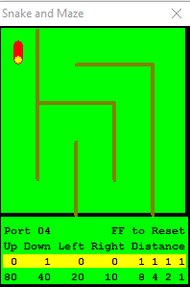

As we can see from the output, the maximum distance value of 15 is fine to use, as the snake has not travelled too far. This means we can keep sending the ALs value to the output as many times as required which will eventually look like:

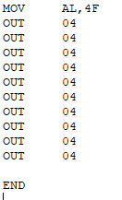

Resulting in:

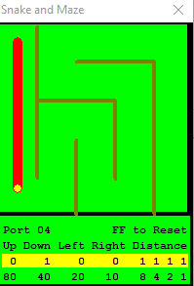

Now we can see that the snake has moved down 10 times.

The process for traversing the maze is the same concept, with simple adjustments to the direction and distance as required, keeping the snake within the boundaries of the maze.

The output result for a fully completed source code will look like:

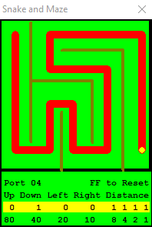

This is the output of my Snake1.ASM

This concludes the tutorial for the Snake and Maze.

### Optimisation

As part of Task 2 of the assignment, I used a loop to make the program more efficient.

The following is the loop I have used, and an explanation of what it is:



This loop is essentially a modern language while loop, and a high-level overview is:



Using the following code from the Snake2.ASM we can interpret the loop further:

**ASM Instruction:**



**Interpretation:**



This will keep on repeating itself for each declaration of MOV AL, MOV BL and CALL until it hits the end command.

### Observation and Review

After both solutions had been created, I decided to do some testing on each one. The results, although not what I was expecting, made sense. I initially thought that the second solution would be more efficient on both the CPU and the memory, but this was not to be the case:  
  
**Test Environment:**

|  |  |
| --- | --- |
| **Processor** | x64 based Intel Core i7 |
| **Operating System (not relevant in test)** | Windows 10 |
| **Memory** | 8GB DDR4 SDRAM |
| **CPU Speed Increment** | 3 Clicks of the ‘Faster’ button (increments of x2) |
| **Distance Moved** | 15 Hexadecimal |

**Solution One – CPU**

Running the first solution under the normal CPU speed took 37.5 seconds to complete.

The CPU Usage fluctuation throughout but had an overall average of 1.0% utilization of the CPU.

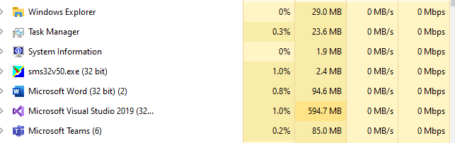

Running the test again at 3x speed, I observed that the completion time was 6.02 seconds and the CPU usage averaged at 1.9%.  
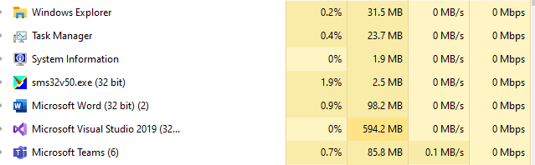

**Solution One – Memory**

The memory usage should remain constant regardless of the CPU speed and tests show this to be true; the memory usage was over half of the memory available to the simulator.

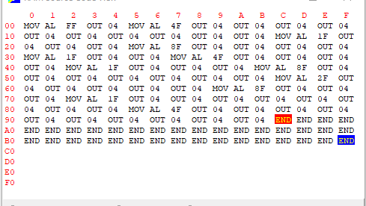

**Solution Two – CPU**

Running the second solution under the normal CPU speed took 134.2 seconds to complete.

The CPU Usage fluctuation throughout but had an overall average of 0.7% utilization of the CPU.

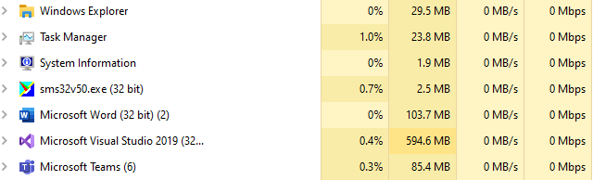

Running the test again at 3x speed, I observed that the completion time was 22.3 seconds and the CPU usage averaged at 1.4%.  
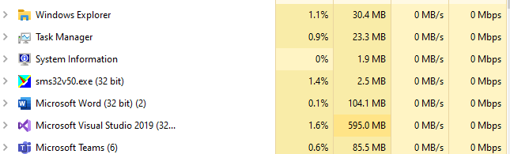

**Solution Two – Memory**

This solution used almost less than half of the memory that the first solution used.

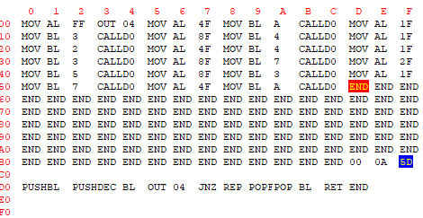

**Test Comparison**

Each solution had three tests performed on it for a fair analysis. The results above reflect the average over the three tests.

It is fair to say that ‘efficiency’ may not always be without drawbacks, and it is about finding a balance between the two. For example, results show that the second solution, whilst consuming less memory and utilizing less of the CPU, took substantially longer to run and complete. One can argue that if this were an application designed for a smooth user experience, the ‘optimization’ will not have been suitable to use in production.

**Simulator vs My/Modern CPU’s**

# Fetch-Decode-Execute Cycle

### Brief

Fetch-Decode-Execute refers to the primary process that a CPU performs to execute programmes. This cycle begins as soon as a computer is switched on by loading the programme into the main memory (RAM)

### Terms

**Program Counter (PC)**

A register in a computer processor that contains the memory locations (memory addresses) of the next instruction being executed for a particular programme. When a programme is loaded, the first memory address is passed into the program counter, which in turn passes this to the **MAR**. The program counter then increments the value stored in its counter by one.

**Memory Address Register (MAR)**

This register contains the memory address of the current instruction that is to be fetched from memory and is connected only to the CPUs address bus - the MAR is the only way a CPU can communicate with this bus. The MAR contains two different types of addresses: the address of the current instruction; the address of a piece of data that is transferred to the MDR/MBR. Typically, the **MAR** works with the **MDR.** First the MAR sends the memory address across the address bus into memory, decodes the instruction in that address and then sends it down the data bus to the **MDR.**

**Memory Data Register (MDR)**

Also known as the Memory Buffer Register, it is comparable to the **MAR**, but uses the data bus instead of the address bus. Another difference is that the **MDR** can not only load data from the data bus, but also store it as well, both using the address stored in the **MAR**.

**Current Instruction Register (MDR)**

This register holds the instruction that is currently being executed or decoded by the CPU. The value held in here is obtained from the **MDR.**

**Arithmetic Logic Unit (ALU)**

This is where the CPU performs all its mathematical operations, hence the name ‘Arithmetic Logic’. By nature, the ALU does not always need to be used. For example, storing a value in memory does not explicitly perform a mathematical or logical process.

**Arithmetic**

Mathematical operations such as addition and subtraction, multiplication, and division.

**Logic**

Logical comparisons such as OR, AND, and XOR.

The ALU works with multiple circuits that do mathematical and bitwise operations on binary numbers and contains two inputs: the first is an operand, which is essentially the piece of date that is going the have the operations performed on; the second is the actual operation that is going to be performed on the operand.

In the ALU are signal receivers for each of the inputs. The calculations are performed when a signal is sent to one of these inputs.

**Accumulator (ACC)**

This is a register inside of the ALU that stores the intermediate results of the operations performed by the ALU.

### Assignment Task

Below is the tri-cycle task in which the three cycles for the Fetch-Decode-Execute Cycle are performed using the data provided.

**Cycle One**

1. The programme begins at the first memory address for it, and the PC initially contains the memory address for the next instruction which is going to be executed. In this case it is the address 67 (start address).
2. The PC then increments by one (68) and places the current value (address location 67) into the MAR.
3. As mentioned earlier, the MAR then sends the memory address stored in it across the address bus and finds the corresponding instruction in that location, which here is ‘LOAD 71’.
4. This is then returned to the MDR via the data bus.

ACC

CIR

MDR

**MDR <- [Memory] PC <-[PC]+1**

**MAR address;**

PC

MAR

68 [+1]

67

LOAD 71

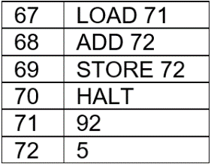

1. The MDR then passes the instruction to the CIR.

ACC

CIR

MDR

**CIR <- [MDR]**

PC

MAR

68

67

LOAD 71

LOAD 71



1. The CIR then decodes and executes this instruction by loading the value of memory address 71 and placing it in the ACC.

ACC

CIR

MDR

**[CIR] Executes**

PC

MAR

68

67

LOAD 71

LOAD 71

92



**Cycle Two**

1. Still in the same programme, the cycle starts again, and the PC contains the memory address for the next instruction to be loaded (68).
2. The PC then increments by one (69) and places the current value (address location 68) into the MAR.
3. The MAR then sends the memory address stored in it across the address bus and finds the corresponding instruction in that location, which this time is ‘ADD 72’
4. This is then returned to the MDR via the data bus.

ACC

CIR

MDR

**MDR <- [Memory] PC <-[PC]+1**

**MAR address;**

PC

MAR

69

68

ADD 72

92



1. The MDR then passes the instruction to the CIR.

ACC

CIR

MDR

**CIR <- [MDR]**

PC

MAR

69

68

ADD 72

ADD 72

92



1. The CIR then decodes and executes this instruction by first loading the memory address, decoding it, and then executing the instruction. This time the instruction is sent to the ALU which then performs: ADD 5 to ACC (92), which becomes 97. This is then stored in the ACC.

ACC

CIR

MDR

**[CIR] Executes**

PC

MAR

69

68

ADD 72

ADD 72

97



**Cycle Three**

1. Again, in the same programme, the cycle starts again, and the PC contains the memory address for the next instruction to be loaded (69).
2. The PC then increments by one (70) and places the current value (address location 68) into the MAR.
3. The MAR then sends the memory address stored in it across the address bus and finds the corresponding instruction in that location, which this time is ‘STORE 72’.
4. This is then returned to the MDR via the data bus.

ACC

CIR

MDR

**MBR <- [Memory] PC <-[PC]+1**

**MAR address;**

PC

MAR

70

69

STORE 72

97



1. The MDR then passes the instruction to the CIR.

ACC

CIR

MDR

**CIR <- [MDR]**

PC

MAR

70

69

STORE 72

STORE 72

97



1. The CIR then decodes and executes this instruction by first loading the memory address, decoding it, and then executing the instruction. This time the instruction is ‘STORE in memory address 72’, so the CIR sends the value in the ACC back down the data bus to the MDR. The MDR then stores the value into memory address location 72.

ACC

CIR

MDR

**[CIR] Executes**

PC

MAR

70

69

STORE 72

STORE 72

97

